AIAA Houston invites you to attend a speaker presentation dinner in College Station, Texas.
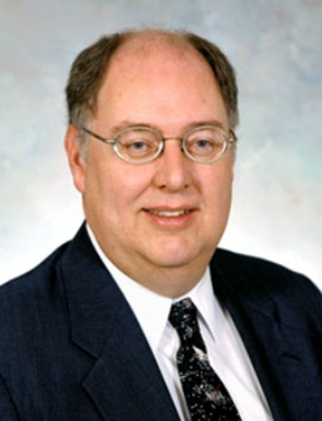
Speaker: Mr. Wayne Hale, former NASA Space Shuttle Flight Director
Title: “Where Are We Going in Space?”
Date: Tuesday, November 15, 2016
Time: 6 p.m. – 8 p.m.
Location: Science Park cafeteria
2501 Earl Rudder Freeway South
College Station, TX 77845
Dinner from Freebirds will be available for $10 for AIAA members, $12 for non-members, and $5 for students with ID. To register for your dinner or for more information, go to http://www.aiaahouston.org/Nov2016Dinner.
The presentation is free.

