“Lunch-and-Learn” Space Operations Technical Chair Presents
VASIMR® Propulsion Development - Ready for the Next Level
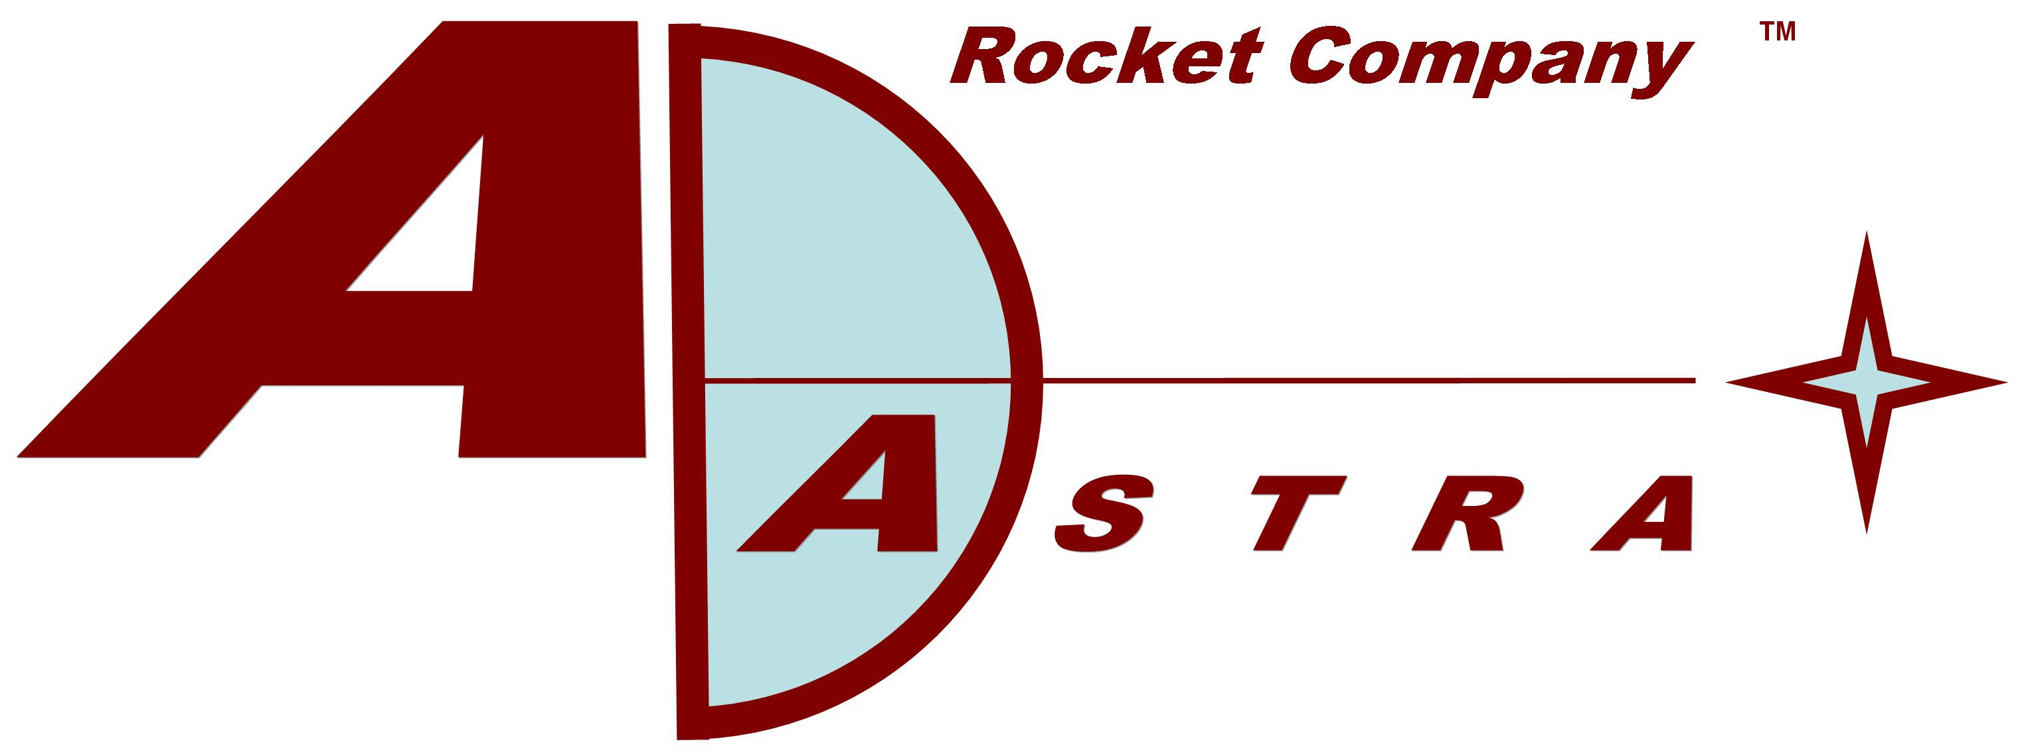

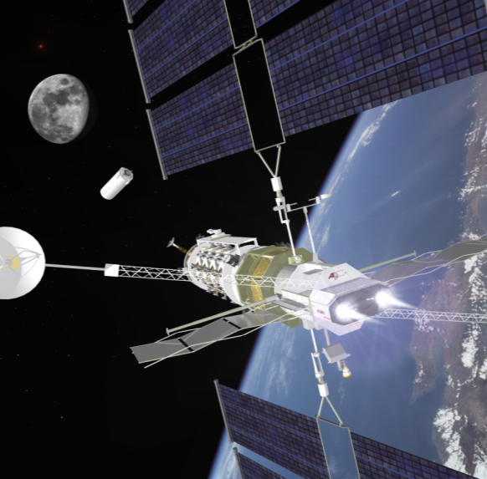

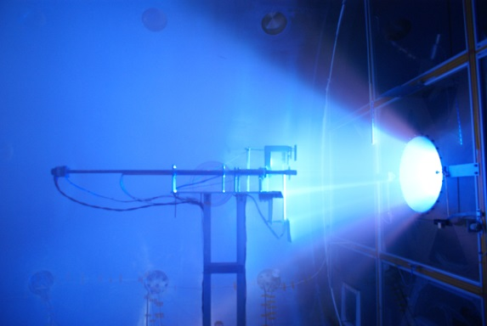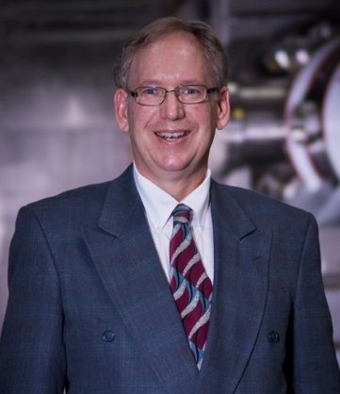

Dr. Jared P. Squire, Ad Astra Rocket Company
NOV 13 2014; University Space Research Association (USRA)
3600 Bay Area Blvd Houston, TX 77058 in the Berkner Room from
11:30 AM 1:00 PM RSVP using this link www.aiaahouston.org and EventBrite
Invitation Link for Jason’s Deli provided, or you may bring your own lunch with you.

There is a growing consensus that Solar Electric Propulsion (SEP) in the multi-100 kW class will be highly valuable – if not essential - for human exploration of deep space. This technology enables tremendous robotic cargo delivery to distant locations, such as Mars, when time is not a major factor. The necessary power levels to serve the mass of human-supporting payloads are more than ten times that of the state-of-the-art SEP. Human transportation history shows that desire and need for power always grows. Space is no different. Human space exploration will soon desire multi-MWs, so we should invest in technology that can grow to this capability. The VASIMR®-SEP technology starting at power levels of 50 kW (about that of a small electric car) coupled with ongoing innovations in solar power is such a system. This talk will review the high state of the technology readiness of a VASIMR® system. The physics and system efficiency have been proven in our Webster facility. The technology is ready for the next level of ground testing, thermal steady-state, on its way to spaceflight testing. Engineering system analysis shows that, in the power realm above 50 kW, a VASIMR® propulsion system is unmatched in performance.

Dr. Jared P. Squire has been a key member of the VASIMR® technology development team since 1995. He began his career at MIT while studying high-power (MW) RF driven magnetized plasmas for nuclear fusion energy. Dr. Squire helped establish a laboratory at the Johnson Space Center that performed the early experimental research that demonstrated the physics of the VASIMR® engine. One of the original founders of the Ad Astra Rocket Company and a member of the Board of Directors since its inception in 2005, he is also Ad Astra’s Senior VP of Research and responsible for the continued research to ready the VASIMR® technology for commercialization.

This event is open to all interested attendees. We use different services now from Jason’s Deli Delivery and depend on what venue is secured. Regardless all L&L’s start at 11:30 AM. Professional Engineers earn one hour of credit toward Continuing Education requirements by attending this event. For additional information please contact BeBe Kelly-Serrato, Space Operations Technical Committee Chair at 281.798.9060 or bserrato@a-scc.com

