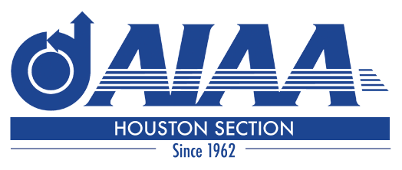
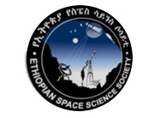

A Proclamation issued jointly by
The Houston Section of
The American Institute of Aeronautics and Astronautics (AIAA) and
The Ethiopian Space Science Society (ESSS)

Whereas The American Institute of Aeronautics and Astronautics Houston Section welcomed Ethiopian guests of honor for our December 2015 dinner meeting in Space Center Houston, including two scientists of the Ethiopian Space Science Society, following the initiative of
Angela Beck Angela Beck
and
Whereas AIAA and ESSS are professional societies with member scientists and engineers working to advance the arts, science and technology of space science and related fields both nations, and
Whereas ESSS and AIAA Houston Section share many technical interests and both work to be of service to our professions and to improve the lives of people everywhere, and
Whereas it is the desire of the members of ESSS and AIAA Houston Section to establish and recognize a special relationship fostering good will and understanding between their members,
Now, therefore, do they declare themselves to be
Sister Sections
and do extend the hand of friendship, and the pledge of cooperation in all things as befits this relationship.

Houston Texas USA: February 7, 2017 Addis Ababa, Ethiopia, February 7, 2017

Jennifer Wells, Chair Jennifer Wells Mesenbet Shenkute, Chair Mesenbet Shenkute

Thomas Haregot, P.E. Thomas Haregot Dr. Tulu Besha Bedada Tulu Besha Bedada

Dr. Yared Kidane Yared Kidane Dr. Berhan Gessesse Berhan Gessesse

