Bomb Shot: A Nuclear Runway
A. A. Jackson, Ph. D, AFAIAA, FBIS
Triton Systems, LLC, Houston (TX), USA
Abstract
This paper investigates the feasibility and physics of a nuclear pulse propulsion concept inspired by Liu Cixin’s Remembrance of Earth's Past trilogy, in which a spacecraft sail is accelerated by a linear array—or “runway”—of thermonuclear devices. This concept is a novel variant of Project Orion [1] and Solem’s Medusa [2] which replaced a pusher plate with sail driven by collimated nuclear plasma bursts and is not constrained by the rocket mass ratio. Using established models from Solem’s Medusa design, we evaluate velocity increments per pulse, thermal and mechanical constraints on a graphene sail, and derive critical standoff distances governed by tensile strength and sublimation temperature. The delta-v per pulse, sail stress limit distance, and thermal destruction threshold are calculated. The most significant constraint is the temperature state of the sail. A monolayer Graphene sail has singular stress and thermal properties. The physical constraints reveals that pulse shaping is demanded. A simple estimation of the mission operation is presented with the timing and spacing of the pulse units.
1.0 Introduction
The mission goal is to accelerate a scientific probe , configured with a sail to at most 0.2c using shaped nuclear devices. The pulse units are placed on a runway using a sequence of nuclear pulses as propulsion to a final speed of .1 or .2 the speed of light. Nuclear pulse propulsion has a long history, we can key off these engineering models, in particular Project Orion [1] and Medusa [2]. The runway concept circumvents the mass ration rocket equation problem.
One envisions a sail-like probe with an embedded scientific payload, guidance, navigation and control system and structural support. The main constraints are mechanical stress, thermal survival and acceleration limits on the instrumentation. A good guess at structural material is graphene. Graphene has a tensile strength of 130 GPa and a possible sublimation temperature of 4000 to 4500 degrees K. The number of nuclear pulse units will be limited to 1000 or less and yields of 1 to 10 kilotons. This is probably a difficult array of such devices since they would have to be placed in a suitable orbital configuration each with its own GNC system for proper phasing of the launch process. The equipment should not be subjected to accelerations exceeding 20,000 gs.
2.0 Modeling Engineering Constraints
Like the Orion Project, take the pulse units to be directed nuclear explosion devices (Casaba-like) devices [3], [4], [5].)

2.1 Velocity Gain Per Pulse.
There are import propulsion constraints. Estimate the delta v delivered by the pulse unit. A mass is converted into a directed plasma beam, M_{b}. in a nuclear device and is ejected with velocity $v_{b}$, the total momentum in the beam is:
$$p_{b}=M_{b}v_{b} (1)$$
If this beam strikes the sail and fully transfers its momentum (ideally inelastic impact) the sail, of mass M_{s,} absorbs this momentum:
$$Δp=M_{b}v_{b}=M_{s}Δv (2)$$
Hence, the delta-v of the sail is:
$$\boxed{Δv=\frac{M_{b}v_{b}}{M_{s}}} (3)$$
Estimate the velocity of the beam. The directed beam gets its energy from the kinetic energy derived from a fraction $η$ of the total yield $Y_{e}$. Assume all that fraction goes into kinetic energy of the beam:
$$Y_{e}=\frac{1}{2}M_{b}v_{b}^{2}⇒v_{b}=\sqrt{\frac{2Y_{e}}{M_{b}}} (5)$$
Substitute into the Δv expression:$Type equation here.$
$$Δv=\sqrt{\frac{2ηY_{e}M_{b}}{M_{s}^{2}}} (6)$$

2.2 Stress Constraint.
Compute the mechanical constraint … which is that the tensile strength of the sail is not exceeded. The impulse delivered by the pulse causes mechanical stress $σ_{m}$ on the sail. The impulsive force can be expressed a
F $= \frac{M_{s}Δv }{Δt}$ (8)
M_{s} is the mass of the sail and Δt is time interval. The pressure on the sail is
$P= \frac{M_{s}Δv}{πΔtR_{s}^{2}}$ (9)
Where R_{s} is the sail radius, for a pulse that is directed perfectly plume and fills the sail, it is the time interval of the pulse that is the constraint. For P, $P<σ$ , the stress on the sail is the impulse time that is limited. If $σ_{yield }$is the limiting stress of the sail, then using (6) and (9)
$Δt ≥ \frac{\sqrt{Y_{e}M_{s}}}{σ_{yield}A_{s}}$ (10)

2.3 Thermal Constraint
Estimate the thermal state delivered by the pulse. The energy flux $F$ at distance $R$ from a pulse of yield $Y$ (in Joules) is:
$$F=\frac{f⋅Y}{4πR^{2}} (11)$$
where $f$ is the fraction of pulse energy coupled as directed energy impacting the sail, ($f$ is taken to be 1 for approximate computations).
Assuming a single pulse deposits energy over a short time $Δt$, the maximum temperature the sail reaches relates to absorbed energy per unit area $E_{a}$:
$$E_{a}=F⋅Δt (12)$$
Using the specific heat capacity $c_{p}$ and sail areal density $s=\frac{m}{A}$, the temperature rise $ΔT$ is:
$$ΔT=\frac{E_{a}}{sc_{p}} (13)$$
Rearranged to find max distance $R$ so temperature stays below a $T_{max}$ the melting or sublimation temperature of the sail
$R_{\text{thermal}}=\sqrt{\frac{Y⋅Δt}{4πsc_{p}\left(T_{max}-T_{0}\right)}}$ (14)
where $T_{0}$ is initial temperature (ambient).
An additional constraint is the upper limit of acceleration that the ship payload, control system and support structure can survive. Knowing the individual pulse delta v and time of interaction the acceleration can be computed. A conservative upper limit to acceleration it 20,000 gs (it has been estimated that materials may be used that have a limit of 100,000 gs) [6]. The vehicle structural material that suggests itself it Graphene.

Table 1 Vehicle Physical Constraints
Constraint | Model Value | Requirement
Interface Temperature | $$T_{\text{interface}}≲4500K$$ | Must be < graphene sublimation temp†
Mechanical Stress | Max stress < ${10}^{11} \text{Pa}$ | Must not exceed graphene tensile strength
Acceleration on vehicle | $$20,000 gs$$ | Upper limit on payload, control system and structure.
†Sublimation Temperature Note: Graphene’s sublimation temperature is often quoted at around 3900 K (based on graphite data). However, some literature and simulations suggest values as high as 4500 K for ideal freestanding monolayer graphene under vacuum [7].
For simplicity, set an example vehicle to examine an interstellar mission using a ‘nuclear runway’ to a final speed of .1 and .2 the speed of light.
2.4 Acceleration Constraint
$$\text{Average acceleration over }Δt : \overset{‾}{a} ≈\frac{Δv}{∆t}≤a_{max} ⇒ Δv≤a_{max} ∆t.$$
Suppose the plume ejecta has $Type equation here.$a characteristic velocity $v_{b}$.
For a plume of total mass $M_{p}$:
$$Y_{e}=1/2M_{p}v_{b}^{2}.$$
The total momentum carried in that plume is
$$p_{\text{plume}}=M_{p}v_{b}=\frac{2Y_{e}}{v_{b}}.$$
A sail of geometric area $A$ subtends a fraction
$$f=\frac{A}{r^{2}}.$$
So the sail intercepts a fraction $f$ of the plume’s momentum.

The velocity jump is $Δv=J/M$, so the acceleration-limit condition becomes
$$\frac{1}{M} \frac{A}{r^{2}} \frac{2Y_{e}}{v_{b}} ≤ a_{max} ∆t.$$
Solve for the acceleration-limited standoff $r_{\text{acc}}$:
$$\boxed{ r_{\text{acc}} ≥ {\left[A \frac{2Y_{e}}{v_{e}} \frac{1}{M a_{max} ∆t}\right]}^{1/2} }$$

3.0 Candidate Vehicle
Set a fixed vehicle as model to examine mission objectives.
Table 2. Candidate Mission Vehicle
Vehicle Component | Dimension | Characteristics
Sail | 100 meters radius | Layered Graphene
Sail Layer Thickness | 5 microns | Optimized for thermal flux rejection
Payload Mass $M_{p}$ | 25 kg | Scientific Package
Structure Mass $M_{s}$ with GN&C system | 25 kg | Rigging, sensors and reaction control system.
Sail Mass | 355 kg | Integrated vehicle

This is the ‘canonical’ vehicle. It is a ‘sail’ with an embedded payload with a support structure. The ‘payload’ contains guidance, navigation and control package. It will be ensured that the spacecraft also has an embedded reaction control system. Take sail material to be layered graphene of thickness 5 µm. (Note: it has been difficult to ‘layer’ graphene, that is a technological problem to be solved.)
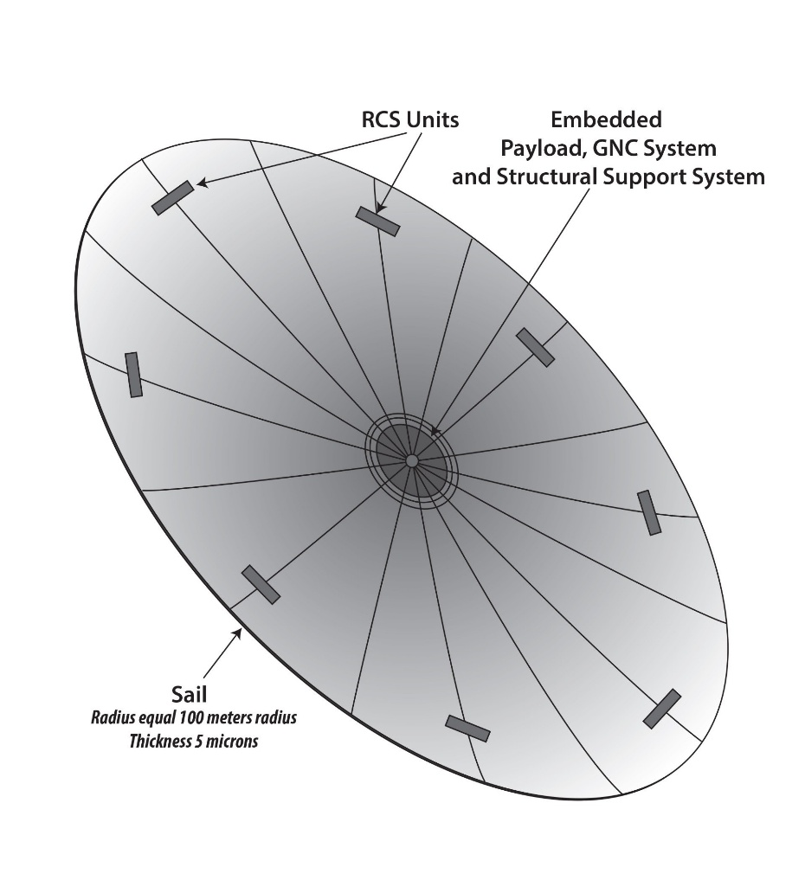
Figure 1. Candidate Vehicle (not to scale).

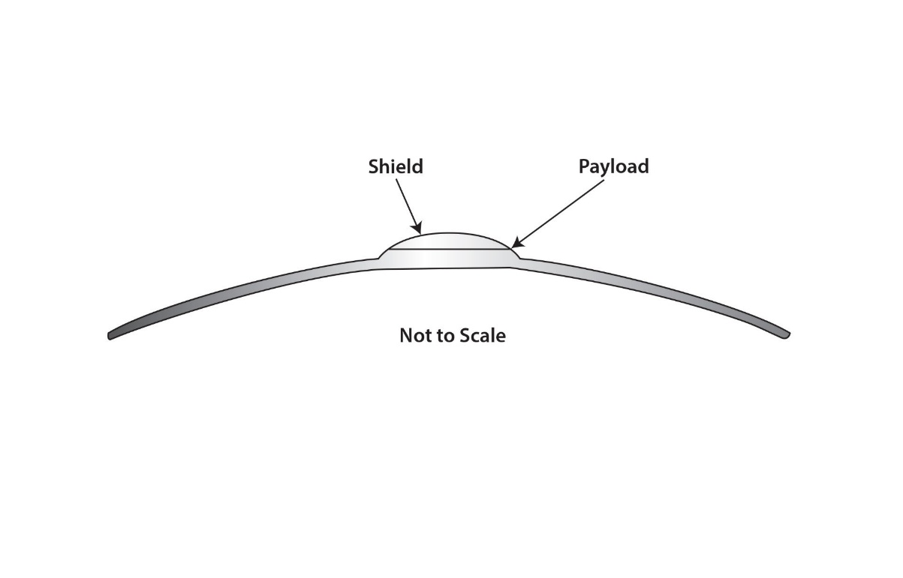
Figure 2. Side view to vehicle.

Table3. The ‘Canonical’ Vehicle Configuration and Mission
Parameter | Value / Range | Notes
Target Final Speed $v_{f}$ | 0.1c 0.2c | Baseline requirement
Restraint on Number of Pulse Units $N$ | 1000 pulses or less | Upper bound
Yield per Pulse $Y_{e}$ | 1–10 kt, shaped / directed | Lower bound set by flux constraints
Coupling Efficiency $η$ | 1.0 | Idealized Casaba like beams (directed explosion)
Sail Radius $R_{s}$ | 100 m | Study Fixed
Sail Material | Graphene | Layered Graphene
Thickness | 5 microns | Graphene has good thermal flux rejection
Scientific Package and  GNC system | 25 kg
Support Structure | 5 kg
Mass of the Sail | 355 kg

Above the physical constraints, thermal, and mechanical were set forth. Apply to a test case.
Figure 3.1 is the mechanical constraint on the pulse time versus Yield.
Figure 3.2 shows the safe standoff distances versus yield for the canonical test vehicle; it shows that the thermal distance constraint dominates the mission state.
Using the thermal constraint fix the standoff distance at 7 km for yields 1kt to 10kt.

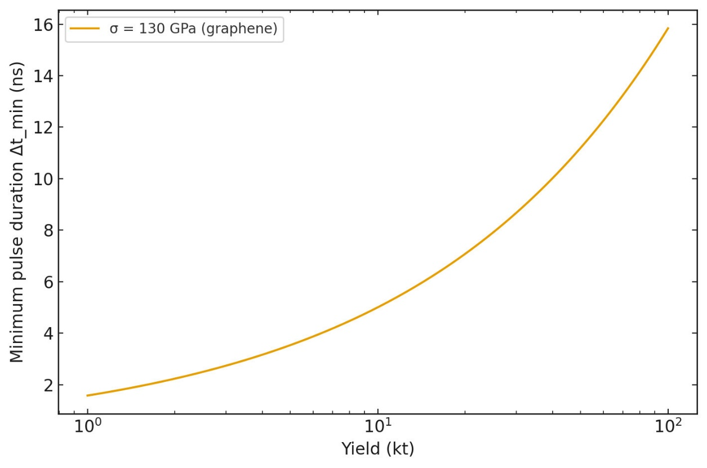
Figure 3.1 Constraint on the pulse time vs. pulse unit Yield.

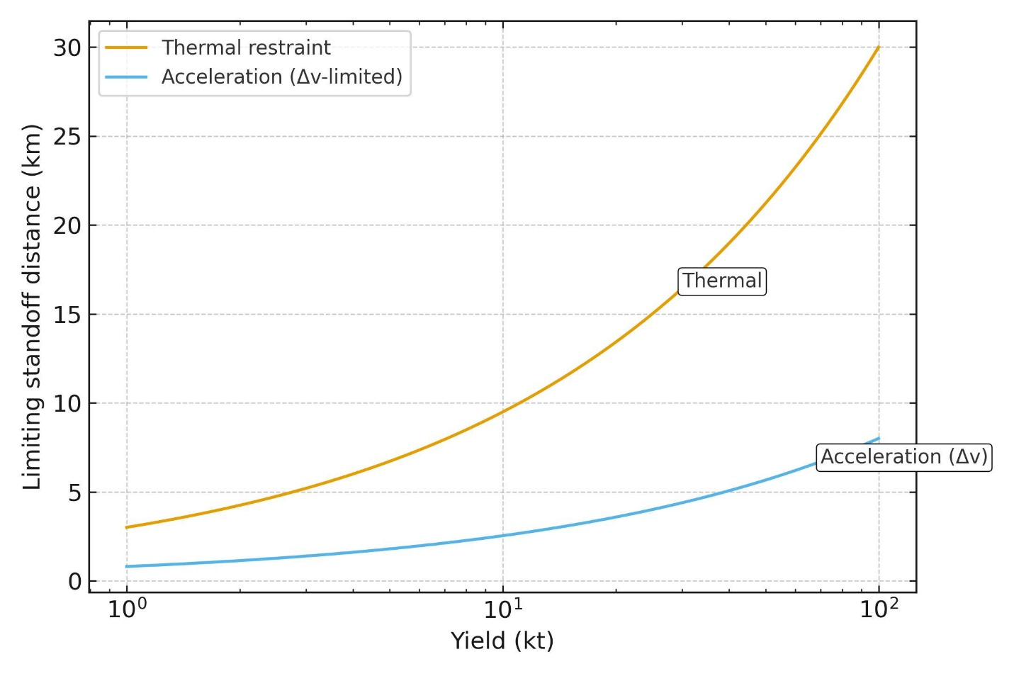
Figure 3.2 Physical constraints.
4.0 Number of Pulse Units
For a fixed standoff distances demanded by the thermal and acceleration limits derived above determine the number of pulse units needed for the delta v per pulse to meet the target final velocity. For the canonical 1 kt, 100 m sail, thickness 5 µm case, and bracketing the standoff distance with $r_{safe}$ = 7 km. Figure 4 presents number of pulse units of a vehicle gaining 0.1 and 0.2c when each pulse is taken to be instantaneous.

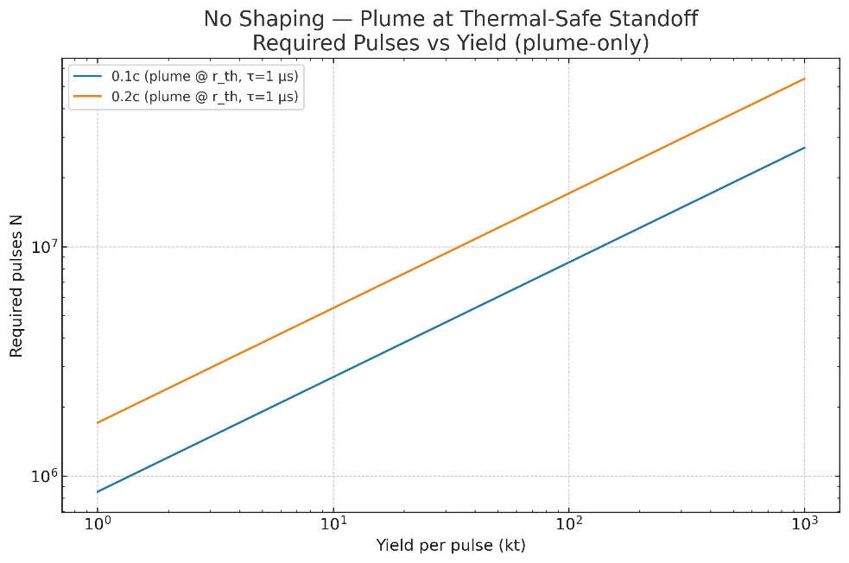
Figure 4. Number of pulses per yield using only safe standoff distances.

Using the safe standoff distance determined by thermal/acceleration constraints the geometric coupling and a very short pulse drives the per-pulse $Δv$ magnitude down to the point that ${10}^{6}\text{ to }{10}^{7}$ pulses are required for $0.1c$ and 0.2c for an ideal beam filling the sail—before even enforcing the acceleration ceiling, which by itself renders instantaneous impulses untenable. These findings motivate a shaped-pulse strategy analyzed in the next section: temporal stretching to meet $a_{max}$, and (consequently) operation at smaller $r$ with greatly improved intercept fraction, cutting the pulse count by orders of magnitude. This suggests temporal pulse shaping may solve the pulse number problem.
5.0 Pulse Shaping
Initial computations with unshaped pulses assumed a prompt deposition of plume energy (microsecond-scale) and safe stand-off distances determined by the thermal, mechanical, and acceleration constraints. Under these assumptions, the runway failed to deliver the desired performance efficiently, forcing the exploration of temporal shaping of the nuclear pulses. A reference to a report by Freeman Dyson suggests a ‘shaping’ the plume with a Gaussian function [8]. (See Appendix A.)
Pick a Gaussian function to see if that ‘smooth’s out the interaction of the sail with the directed plume. Table 4 compares an unshaped with shaped ‘beam’ of plasma expanding in a vacuum. That is shape of ‘shape’ the pulse of energy from each nuclear unit can be described as a normalized Gaussian function in time:
$$S\left(t;σ\right)=\frac{1}{\sqrt{2π}σ}exp​\left(-\frac{t^{2}}{2σ^{2}}\right).$$
The width parameter $σ$ (or equivalently the FWHM, $\text{FWHM}=2\sqrt{2ln2} σ$) sets the interaction time between the plasma plume and the sail. See Appendix A.
Table 5 Pulse processing compared
Factor | Unshaped Pulses | Shaped Pulses
Stand-off distance | Large, reducing coupling | Moderate, efficient
Thermal stress | May exceed sublimation | Controlled, near steady-state
Mechanical stress | Multi-GPa, failure risk | Within graphene’s limit
Number of Pulse Units | Excessive | Manageable
Shaping for smooth acceleration and shaping for survivable heating are related but not identical. It turns out mechanical stress is secondary to heating per pulse. One can make them coincide only if one has enough knobs on the modeling—ideally by decoupling momentum from heat. With a bare graphene foil that absorbs most of the plume KE, the same shaping that gives one uniform acceleration also gives you uniform energy per area, so if that uniform level exceeds the thermal cap, no angular shaping alone will save you. Using the ‘canonical’ vehicle, figures 5 and 6 show the time history of the delta velocity, mechanical stress in Mpa, thermal state in degrees K, and acceleration in gs of a 1 and 2 kt pulse units, optimistic focusing of the directed plume and efficiencies of 1 are assumed.
In these calculations the nuclear pulse is not modeled as an instantaneous impulse. Instead, the deposition of momentum and energy onto the sail is distributed in time with a Gaussian profile, characterized by a width parameter σ. This shaping function conserves the total impulse and energy set by the pulse yield but spreads their delivery across a finite interaction time. The effect is to smooth the rise and fall of the driving forces, avoiding destructive shocks.
The four panels show how this shaping translates into manageable mission constraints:
- (a) Δv time history: The cumulative velocity increment grows smoothly as the Gaussian impulse is integrated. For a 1 kt yield, ~942 pulses are required to reach 0.1 c.
- (b) Mechanical stress: Stress on the sail follows the Gaussian distribution, peaking at mid-pulse and dropping to negligible values before and after. This demonstrates how the shaping bounds the instantaneous load.
- (c) Thermal state: The sail temperature rises as energy is absorbed during the interaction, peaks near the midpoint, and falls as reradiation dominates. By adjusting σ, the peak is held below the sublimation temperature of graphene.
- (d) Acceleration: The acceleration history mirrors the momentum flux, with a Gaussian-shaped peak. Expressed in units of g, it shows whether the design remains within the ~20,000 g survivability limit.
In short, Gaussian pulse shaping distributes the nuclear impulse across a manageable timescale, keeping thermal and mechanical stresses within material limits while still delivering the required Δv. The time history makes explicit how the same shaping function governs all four quantities in a consistent way.

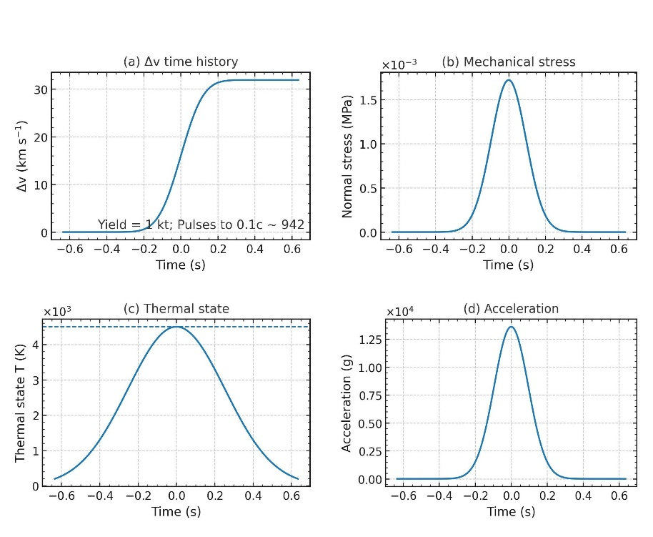
Figure 5. Time history for a 1kt pulse shaped with a Gaussian.

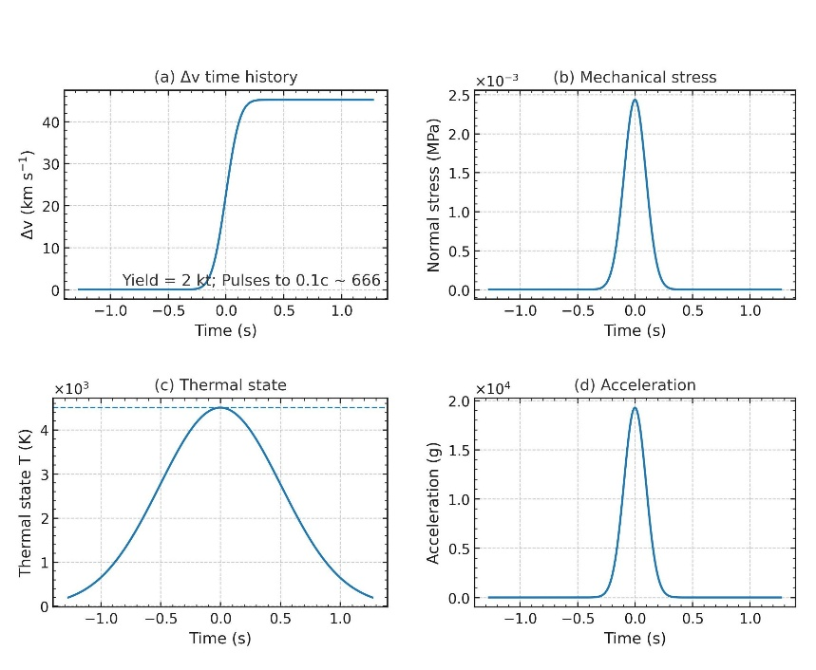
Figure 6. Time history for a 2kt pulse shaped with a Gaussian
The resulting mission values are given in table 7. All the physical constraints are met; the safe standoff distance is set to 7 km for each case. The number of 1kt pulse units for 0.1c is within the 942 inside the 1000-unit limit, while the number of pulse units for 0.2c is 1903. For 2 kt pulse units for 0.1c is 666. The one and two kilotons are conservative picks. The 10 kt case shows a considerable reduction in pulse units. The author is reluctant to pick a more energetic case because of possible acceleration overage.
Table 6 Yield and Count comparisons
Parameter | Yield = 1 kt | Yield = 2 kt | Yield = 10 kt
Peak acceleration (g) | 13618.23 | 19259.1 | 20000.0
Peak normal mechanical stress (Pa) | 721.7 | 2434.8 | 2528.5
Peak temperature (K)* | 4500.0 | 4500.0 | 4500.0
Pulse Delta-v (km/s) | 31.9 | 45.2 | 101.0
Pulses to 0.1c (relativistic) | 942 | 666 | 298
Pulses to 0.2c (relativistic) | 1903 | 1346 | 602

The peak temperature is for the idealized case of the shaped pulse. A more realistic scenario is accounting for the heating and cooling of the sail. Figure 7 shows that the sail’s thermal regime can exceed the thermal constraint for a delta function impuse. On the other hand it stays safely below sublimation temperature of graphene for two different shapings the step function and a gaussian function.
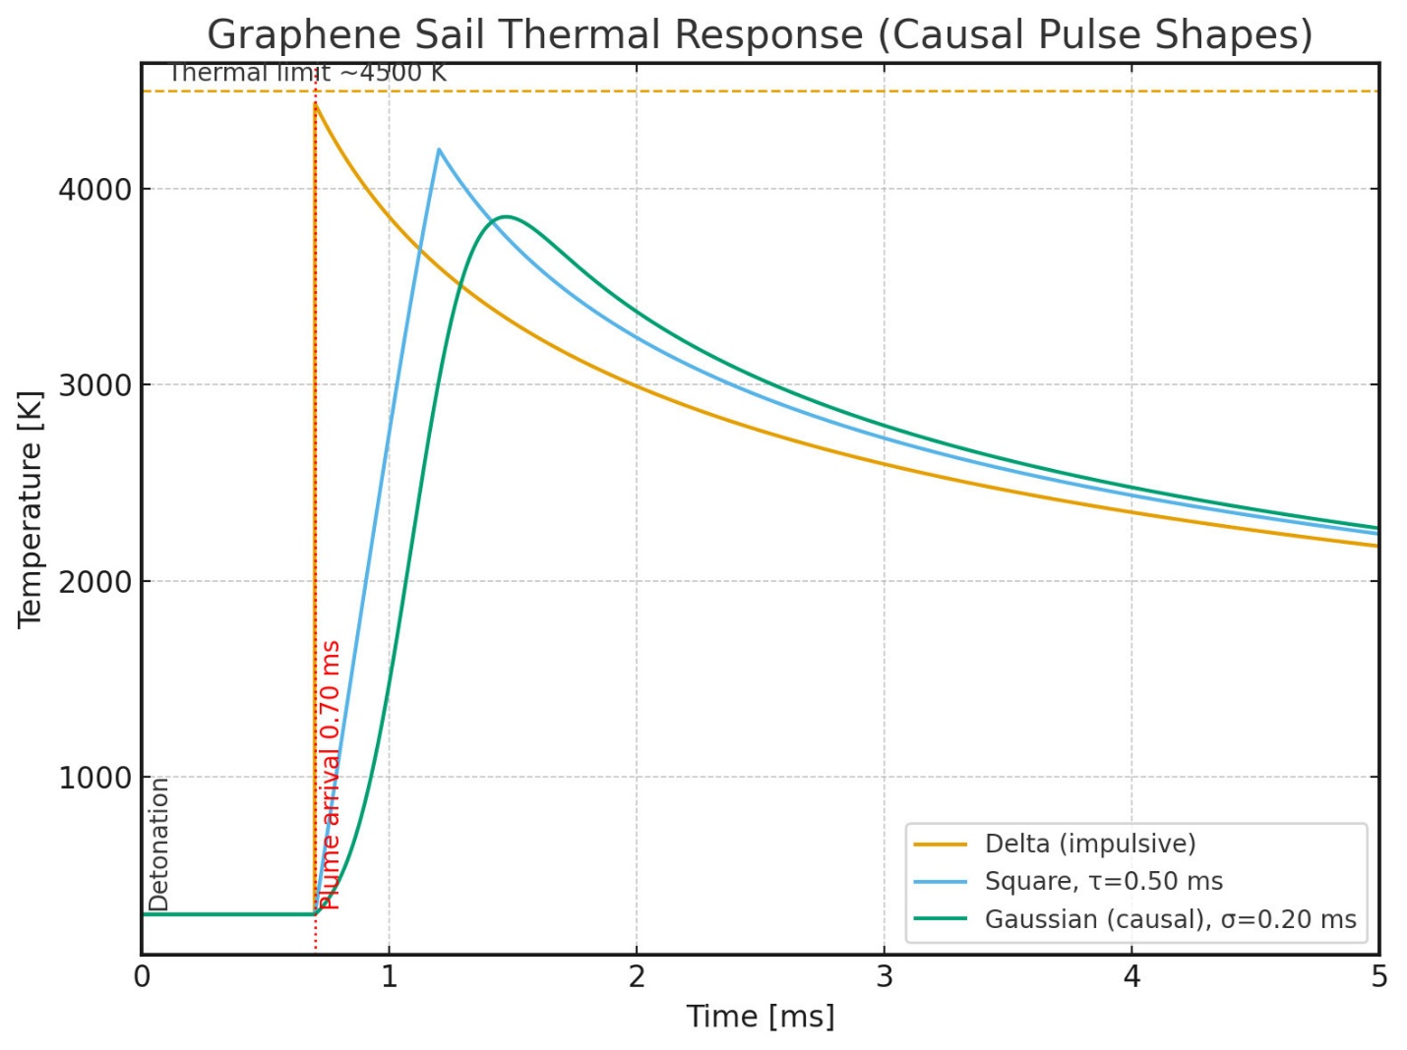
Figure 7. Thermal time history of sail with re-radiation of the pulse heating.
6. The Pulse Unit
“Shaped” nuclear devices—sometimes discussed under the umbrella of “third generation” concepts—aim to steer a portion of a nuclear detonation’s output into a preferred direction rather than radiate spherically. Output is only a mass converted into plasma. (It is possible to consider focused electromagnetic radiation as propellant, but this has proved problematic [9].) The best-known historical occurrence is Project Orion’s work on nuclear pulse propulsion, which explored using bomb-driven directed working masses for thrust. A fission bomb's intense X-ray and gamma radiation is channeled to vaporize a specific material, typically a tungsten ‘liner’. This turned the tungsten into an extremely fast-moving, cigar-shaped jet of plasma [3]. The U.S. also examined weaponized variants popularly referred to as “Casaba-Howitzer,” intended to concentrate energy into a tight cone of plasma [3].
Figure 9 is a representation of an idealized scenario of a single pulse. Shaping the output of a nuclear device means trying to transfer a large fraction of the prompt energy into a directed working mass instead of allowing it to expand quasi-isotopically. 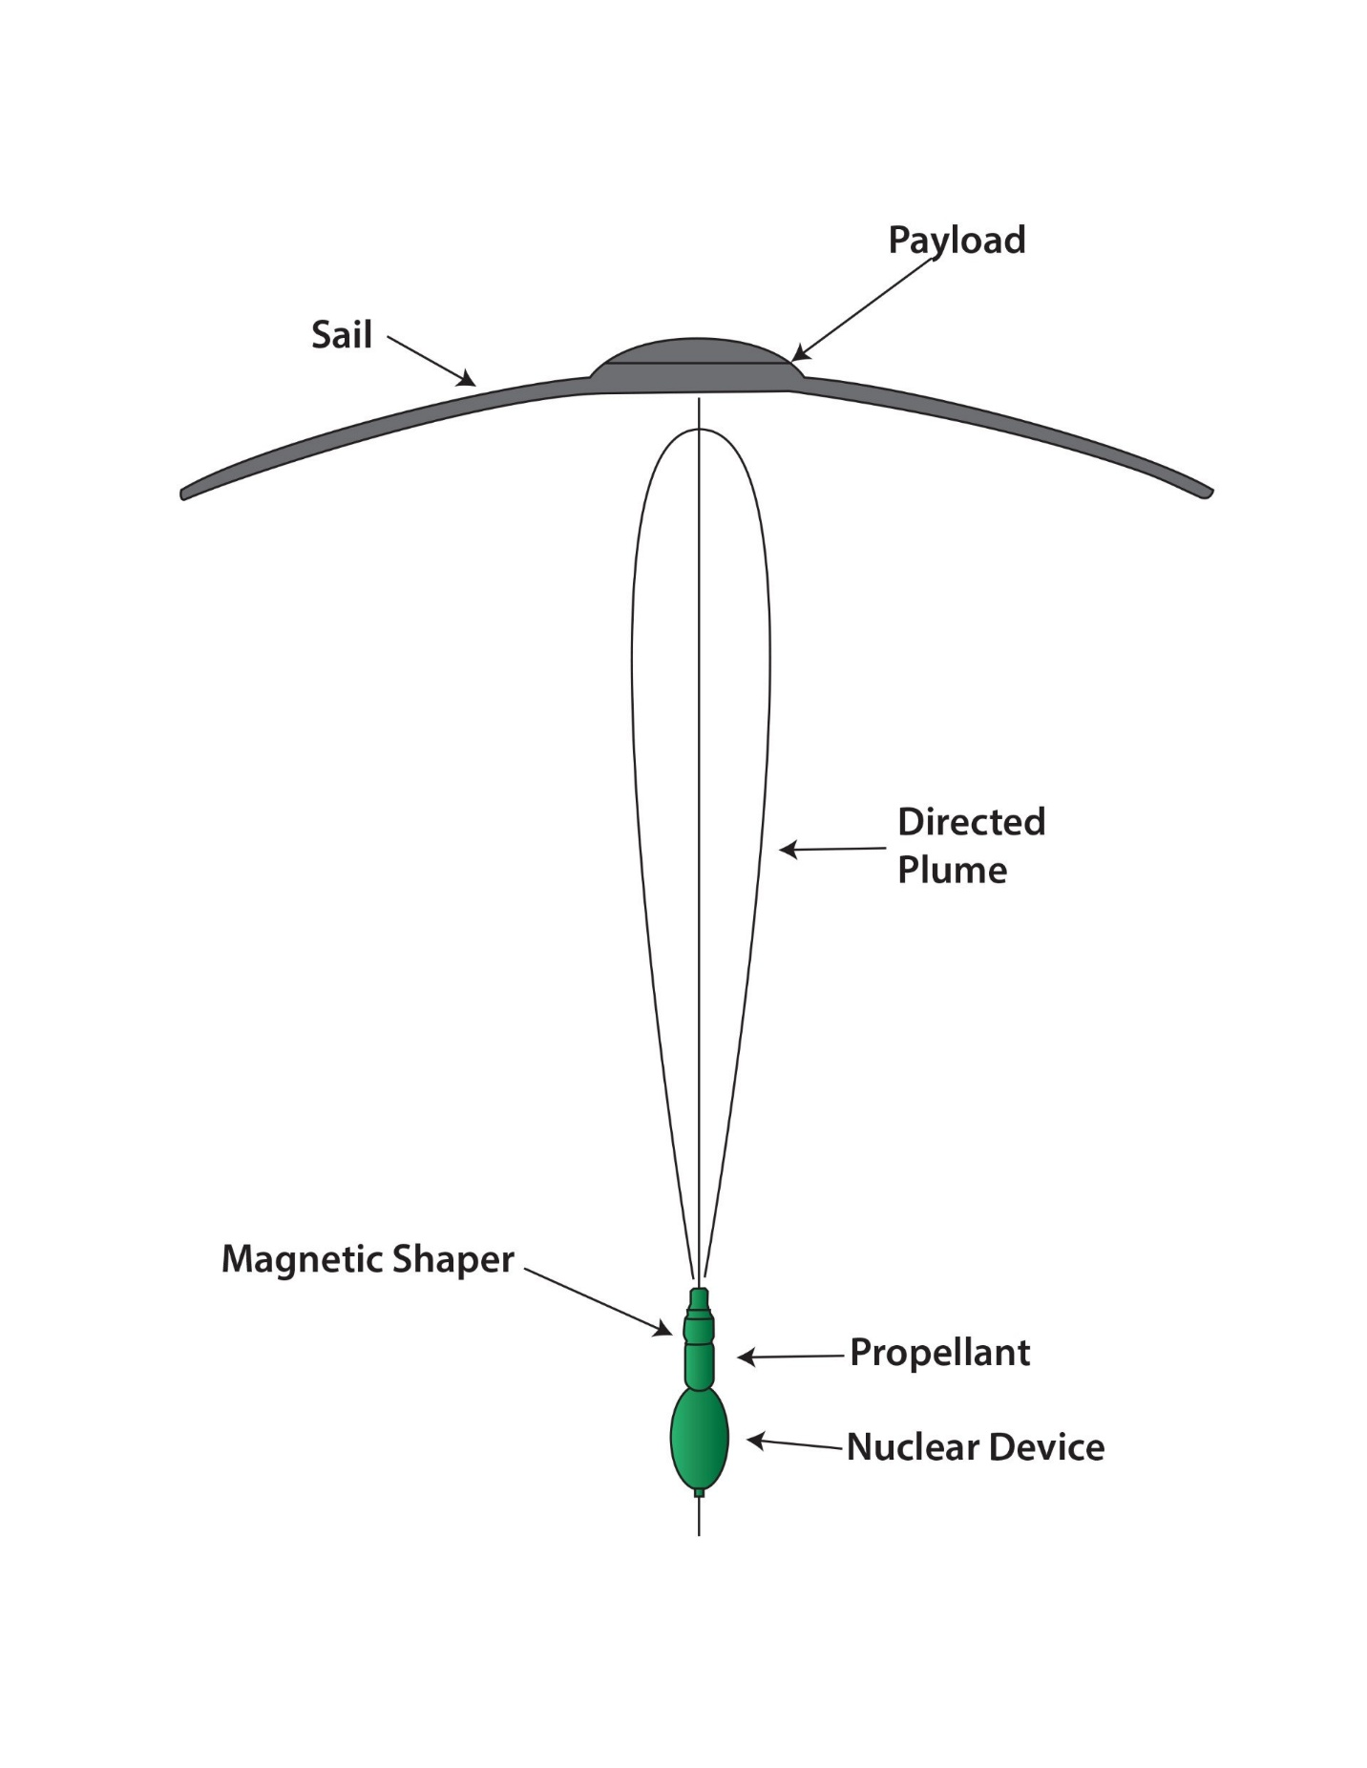
Figure 8. Schematic representation of a single pulse (standoff distance is approximately 7 km).
In principle, materials with high opacity to x-rays can act as crude collimators or “shadow shields,” although survivability under prompt flux is a severe constraint. Any collimator must survive long enough to shape the flux but will become plasma ablation that expands and possibly blurs the pattern. In principle, angularly selective moderators/absorbers/reflectors could produce modest anisotropies in neutron or photon flux. Practically, prompt timing and material survival limit how much directivity you can get from neutral radiation without converting it to a directed plasma first. One possibility is magnetic shaping, though that is mostly conceptual. Charged debris/plasma could, in principle, be steered with transient magnetic fields, but field strengths and hardware survivability at nuclear timescales are extreme. This is a speculative concept for an explosive nuclear device [9],[10]. Columniation of a nuclear explosion into a highly directed plume of plasma is difficult to study, most of the technical research work is highly classified and not in the public domain [5].
For narrow, very fast jets at long standoff (shaped-plume, graphene-sail “runway” use case), an X-ray–driven ablation of a high-Z liner—usually achieved with a fission primary (and/or a thermonuclear stage used chiefly as an X-ray source)—generally delivers higher efficiency and thus higher plume speed at the same yield and liner mass. “Clean” fusion pulses can have higher fuel energy density, but without a converter their spectra are neutron-heavy, which lowers effective coupling to a thin liner and tends to reduce plume velocity.
Table 8 condenses the essential parameters for the canonical graphene sail (100 m radius, 5 µm thickness, ~400 kg total mass) under the 2 kt shaped-pulse case, constrained by a 20,000 g acceleration cap.

Table 8
Parameter | Value / Notes
Sail radius | 100 m
Sail thickness | 5 µm (graphene)
Sail mass | ≈ 355 kg
Total craft mass | ≈ 400 kg
Pulse yield | 2 kt (shaped)
Acceleration cap | 20,000 g
Per-pulse Δv | ≈ 45 km/s
Pulses to 0.1c | ≈ 666
Pulses to 0.2c | ≈ 1346
Safe standoff distance | ≈ 7,000 m
Pulse plume mass | ≈ 50 kg (directed)
Runway length | ≈ 39 lunar distances (~15 million km)
Pulse spacing (initial) | ≈ 20–30 km (near 1 AU)
Pulse spacing (final) | ≈ 30,000–40,000 km (outer runway)
Time to escape Solar System | Weeks
Time to 0.1c | ≈ 800 s cumulative acceleration time
Trajectory | From 1 AU outward, coast out of the solar system

Operation
For the mission the ‘runway’ will have to be put in place by a separate operation. The configuration of the ‘runway’ can be estimated. A constant time between a pulse schedule is an approximate method for mission analysis. Pick one inter-pulse time (Δt) set by your “slowest” constraint (thermal cool-down + control margins) and let the spatial spacing grow with speed: For the 666 0.1 c run, Δt ≈ 1.2 s works cleanly and keeps the whole runway compact and technologically feasible. It is interesting that the runway is 39 Lunar Distances, about 15 million km long. Figure 11 illustrates the length of the runway. Such a ‘runway’ system in the Earth Moon system could be built though from a technological standpoint it would be difficult and expensive. Ten percent of the speed of light is achieved in a relatively short solar system distance, about .03 AU. figure 8.
Modeling the ‘spacing’: Spacing law, sn = n Δv Δt . runway length = $∆t∆v\frac{n(n+1)}{2} ,$representative spacings with Δt = 1.2 s (center-to-center). Table 9 give a representative of spacings.

Table 9 Pulse Spacing
Pulse number | Accumulated Speed | Spacing
Pulse 1 | v ≈ 45 km s⁻¹ | 54 km
Pulse 100 | v ≈ 4 501 km s⁻¹ | 5 401 km
Pulse 400 | v ≈ 18 006 km s⁻¹ ≈ 0.060 c | 21 607 km
Pulse 666 | v ≈ 0.1 c | 35 975 km
Total burn time = $n∆t$ = 799 seconds.
During the pulse sequence the guidance, navigation and control system of the spacecraft and that of the pulse unit ,will be active such that an optimal ‘sail’ attitude is presented to the incoming plume. Figure 12 shows a very approximate ‘runway’ in Earth to Moon distances, LDs.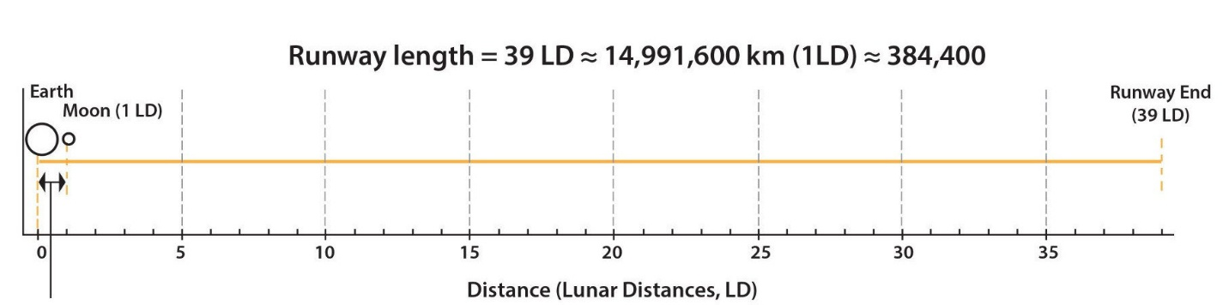
Figure 9 Schematic Example of a Bombshot Runway
Such a mission would probably have a starting point not in Earth orbit, or even at one Lunar distance. Ten Lunar Distances would be more acceptable.
7 Shielding
The spaceship trajectory goes through and outside of the solar system, at 1. or .2 c, on a rectilinear path. Protection of the payload from gas and dust in the solar system becomes an issue that needs to be addressed. After the propulsion phase the ship goes into cruise mode, keeping essentially the same boost attitude—payload still forward. The ‘payload’ employes a forward bumper/shield of Aerographene.
Let a destination is specified, say, Alpha Centauri. Traversing the solar system, the proton density is about 5 cm⁻³, and the dust density is about 10⁻¹⁹ kg m⁻³. In interstellar space the proton density is about 1 cm⁻³, the dust density is about 10⁻²¹ cm⁻³. Take the Scientific payload to be a 1-meter diameter dome, as the principal forward element. Taking the most energetic case, cruising at .2c. During cruise at 0.2c, a forward shield protects the payload from ISM/zodiacal dust and gas.
Model the gas impact due to dynamic pressure and kinetic energy flux. Gas sputtering and dust hypervelocity erosion is the result [10]. One can construct a table of shield weathering, Table 9. Survival of mission seems likely. Values are order-of-magnitude taking dust/gas ≈ 1%, ISM n = 0.1–1 cm⁻³; gas sputter yield 10⁻⁴–10⁻³; 'Shielded' = heavy-margin disk in front of 1 m payload
Table 9 Erosion & Risk Summary
Leg & Speed | Gas erosion | Dust Erosion | Catastrophic dust risk (mission-ending)
Solar System ~100 AU 0.1c | Shielded: ≪ 0.001 nm | Shielded: ≪ 0.1 nm | Shielded: negligible
Solar System ~100 AU 0.2c | Shielded: ≪ 0.001 nm | Shielded: ≪ 0.1 nm | Shielded: very low
Interstellar 4 ly @ 0.1c | Shielded: ~0.003–0.03 nm | Shielded: ≪ 1 nm | Shielded: very low
Interstellar 4 ly @ 0.2c | Shielded: ~0.003–0.03 nm | Shielded: ≪ 1 nm | Shielded: very low

8 Conclusions
The following are the characteristics of this approximate analysis of the nuclear runway.
1. Constraint Analysis – Among mechanical, thermal, and acceleration limits, the thermal constraint (graphene sublimation) dominates the required standoff distance. Without shaping, this forces standoffs of several kilometers and renders the runway impractically long and the number of pulse units excessive.
2. Pulse Shaping as Enabler – Temporal Gaussian shaping of nuclear pulses reduces peak heating and stress, allowing operation at safe ~7 km standoff distances. This increases coupling efficiency and lowers the number of pulses by orders of magnitude. Extremely precise pulse shaping is a speculation it may not be a possibility [11].
3. Canonical Case Results – For a 100 m radius, 5 µm thick graphene sail of ~400 kg mass:
• 1 kt pulses require ~942 shots to reach 0.1c.
• 2 kt pulses reduce this to ~666 shots.
• 10 kt pulses achieve 0.1c in ~298 shots but approach acceleration and stress limits.
4. Runway Feasibility – The runway length for the 2 kt case (~39 lunar distances, ~15 million km) is daunting but potentially constructible with autonomous placement of pulse units.
5. Shielding Requirements – At cruise speeds up to 0.2c, payload survival requires forward Whipple-like shielding. The added mass is small compared to sail mass and does not materially change pulse counts.
6. Engineering Outlook – The nuclear runway concept is theoretically consistent within known material limits, but it depends on advanced nuclear pulse-shaping devices beyond today’s demonstrated technology. Key open problems are:
• Feasible design of Casaba-like shaped nuclear charges.
• Precision deployment and synchronization of hundreds of pulse units.
• Robust sail deployment and guidance, navigation and control of both the sail-ship and the pulse units.
Both the pulse units and sail-ship will have to be self-contained systems, even if there is master control center somewhere.
Overall, the runway concept provides a physically grounded pathway to ~0.1c interstellar probes using nuclear technology, but realization requires breakthroughs in nuclear device shaping, deployment logistics, and long-duration spacecraft survivability. It is interesting that it is an Orion-like system that does not depend on the rocket equation. However, this nuclear detonation system is not superior to directed energy propulsion, driven by a laser array, like Starshot [12].
The reader should note that the idea of the ‘runway’ for spaceflight had been suggested a few times in the history of this subject, see [13] for a complete set of references.

Acknowledgements
Illustrations by Robin Hart.

Appendix A Gaussian Pulse Shaping

1) Notation (time-domain shaping)
Pick a normalized shape $S\left(t;σ\right)$ with one width parameter $σ$ such that
$$\int_{-∞}^{∞}{S}\left(t;σ\right) dt=1, S_{max}\left(σ\right)≡\max_{t}S\left(t;σ\right).$$
Examples:
- Gaussian: $S\left(t;σ\right)=\frac{1}{\sqrt{2π} σ}exp​\left(-\frac{t^{2}}{2σ^{2}}\right)$ so $S_{max}=1/\left(\sqrt{2π} σ\right)$.
Let
- $A_{\text{sail}}$ = illuminated sail area,
- $m$ = total accelerated mass,
- $f$ = geometric/coupling intercept factor (0–1),
- $J_{a}$ = areal impulse delivered to the sail $\left[N s/m^{2}\right]$,
- $E_{a}$ = areal energy absorbed by the sail $\left[J/m^{2}\right]$.

Shape pressure and heat flux as
$$p\left(t\right)=J_{a} S\left(t;σ\right), q″\left(t\right)=E_{a} S\left(t;σ\right).$$
(So, the integrals $∫p dt=J_{a}$ and $∫q″ dt=E_{a}$ are set by mission/device choices; the peaks scale like $S_{max}∝1/σ$.)

th2) First choose the amplitude(s) $J_{a}$ and $E_{a}$
This is set by mission needs and device physics, not the shaper:
- Specify a target per-pulse $Δv$, then
- $J_{a}=\frac{m Δv_{\text{pulse}}}{A_{\text{sail}} f}.$
- (Impulse balance: $∫F dt=m Δv$, with $F=A_{\text{sail}}f p$.)
- $E_{a}$ comes from the device yield, partitioning, and geometry:
- $E_{a}=\frac{χ_{\text{heat}} Y_{​e}}{4πr^{2}} Φ_{Ω​→\text{sail}},$
- where $Y_{​e}$ is the explosive energy, $χ_{\text{heat}}$ the fraction that reaches/absorbs at the interface, $r$ the standoff distance, and $Φ_{Ω​→\text{sail}}$ the directed solid-angle/intercept factor.
Two useful coupling identities (pick the one that matches the pulse physics):
For Plasma drive with effective exhaust speed $u$ (inelastic limit): $J_{a}≈\frac{2 E_{k,a}}{u}$ where $E_{k,a}$ is the kinetic portion of $E_{a}$ that impinges.
At this stage $J_{a}$ and $E_{a}$ are fixed numbers for the given pulse. Shaping will now spread them in time to meet restraints.

3) Then pick the width $σ$ from the restraints
All three restraints are “peak-limited,” and since $p_{max}=J_{a}S_{max}$ and $q″_{max}=E_{a}S_{max}$, making the pulse wider (larger $σ$) reduces peaks while leaving the integrals unchanged. For the Acceleration (g-limit)
$$a\left(t\right)=\frac{A_{\text{sail}}f}{m} p\left(t\right), a_{max}=\frac{A_{\text{sail}}f}{m} J_{a}S_{max} ≤ a_{\text{lim}}$$
which gives the width requirement
$$\boxed{ S_{max} ≤ \frac{m a_{\text{lim}}}{A_{\text{sail}}f J_{a}} }$$
For a Gaussian:
$$\boxed{ σ ≥ \frac{J_{a}}{\sqrt{2π}} \frac{A_{\text{sail}}f}{m a_{\text{lim}}} }$$
(For a rectangle of duration $τ$, replace $σ$ by $τ$ and drop $\sqrt{2π}$.)

(ii) Mechanical stress (membrane/curvature limit)
For a thin curved shell (paraboloid apex) under quasi-uniform pressure, a conservative bound is
$$σ_{θ,max} ≈ \frac{κ_{\text{geo}} p_{max} R_{c}}{2 t} ≤ σ_{\text{allow}}$$
where $t$ is thickness, $R_{c}$ a local radius of curvature, $κ_{\text{geo}}∼O\left(1\right)$ captures boundary/shape details, and $σ_{\text{allow}}=σ_{\text{yield}}/\text{FS}$. This yields a peak pressure limit
$$p_{max} ≤ p_{\text{mech}}^{*}≡\frac{2t σ_{\text{allow}}}{κ_{\text{geo}} R_{c}}.$$
Using $p_{max}=J_{a}S_{max}$:
$$\boxed{ S_{max} ≤ \frac{p_{\text{mech}}^{*}}{J_{a}} } ⇒ \boxed{ σ ≥ \frac{J_{a}}{\sqrt{2π} p_{\text{mech}}^{*}} } \text{(Gaussian)}$$
(Again, replace $1/\sqrt{2π}$ by 1 for a rectangular pulse.)
Dynamic note. If the rise time competes with the sail acoustic time $t_{s}∼R_{\text{sail}}/c_{s}$, multiply $p_{\text{mech}}^{*}$ by a dynamic factor $K\left(σ/t_{s}\right)≤1$ to keep a safety margin against transient amplification.

(iii) Thermal limit (interface temperature $T≤T_{max}$)
Use the surface energy balance (thin sheet, 1-node model):
$$ρc t \frac{dT}{dt} = α q″\left(t\right) - εσ_{​SB}\left(T^{4}-T_{0}^{4}\right),$$
with absorptivity $α$, emissivity $ε$, and initial $T_{0}$. ($σ_{​SB}$ ​ is the Stefan–Boltzmann constant.)
This has two helpful asymptotic regimes:
- Impulsive ($σ≪τ_{\text{rad}}$): the pulse ends before reradiation matters.
Temperature jump is set by integral energy:
- $ΔT≈\frac{α E_{a}}{ρc t}.$
- Here widening does not help; you must reduce $E_{a}$ (or increase $t$).
- Quasi-steady ($σ≫τ_{\text{rad}}$): the surface radiates while being heated.
Peak temperature follows peak heat flux:
- $α q″_{max} ≈ εσ_{​SB}\left(T_{max}^{4}-T_{0}^{4}\right).$
- With $q″_{max}=E_{a}S_{max}$ this gives
- $\boxed{ S_{max} ≤ \frac{εσ_{​SB}\left(T_{max}^{4}-T_{0}^{4}\right)}{α E_{a}} } ⇒ \boxed{ σ ≥ \frac{E_{a}}{\sqrt{2π}} \frac{1}{q_{\text{allow}}} } \text{with} q_{\text{allow}}≡\frac{εσ_{​SB}\left(T_{max}^{4}-T_{0}^{4}\right)}{α}.$
A useful estimate for the crossover is the radiative time constant
$$τ_{\text{rad}}≡\frac{ρc t}{4 εσ_{​SB} T^{3}}|_{T≈T_{max}}.$$
If the chosen $σ$ ends up $≳τ_{\text{rad}}$, the quasi-steady bound above is the right one.

4) The one-width design rule
Compute each bound and take the largest:
$$\boxed{ σ^{⋆} =max\left(σ_{\text{acc}}, σ_{\text{mech}}, σ_{\text{therm}}\right)}$$
- $σ_{\text{acc}}$ from the g-limit,
- $σ_{\text{mech}}$ from allowable stress,
- $σ_{\text{therm}}$ from the quasi-steady thermal cap (or no feasible $σ$ in the impulsive regime and $αE_{a}/\left(ρct\right)>T_{max}-T_{0}$),
That’s the entire shaping logic in one line: pick $σ$ by the most demanding restraint; pick $J_{a}$ (and $E_{a}$) by mission/device; verify all three.
Note: Graphene has three features of importance to the cooling dynamics.
1. High thermal conductivity (~2000–5000 W/m·K): spreads the absorbed heat across the film quickly, preventing local hot spots.
2. Low areal mass: at 5 μm thickness and 100 m radius, the sail has very little thermal inertia. This makes it thermally responsive: it heats quickly but can also cool rapidly.
3.High emissivity: makes radiative cooling efficient, so temperature can drop substantially during and after the Gaussian pulse. Flat graphene typically has a low emissivity around 0.025, but this can be significantly increased to near-perfect blackbody levels (e.g., >0.99) through nanotexturing or engineered nanostructures
A high sublimation point sets the thermal ceiling. The Gaussian must be wide enough that $T\left(t\right)$ remains below this threshold.
Appendix B Detonation Shaping

What is and isn’t known publicly
Known: The general idea of nuclear shaped charges and Casaba-like devices; their historical context; that x-ray-driven ablation can produce enormous pressures and jet velocities; that tight collimation trades off against efficiency; and that Orion-style propulsion informed some of this thinking.
Unknown/withheld: Specific device geometries, materials stacks, areal densities, timing sequences, and quantitative performance (beam angles, efficiencies) remain largely classified or speculative in public forums. Where numbers appear online, they are typically secondary, anecdotal, or unverifiable; they should be treated cautiously.
Appendix C Payload Shielding
Elaboration of the payload shielding.

Table 10 Payload Configuration
Parameter | Value
Shield diameter (Dₛ) | 1.50 m
Shield area (A) | 1.767 m²
Payload dome diameter (Dₚ) | 1.00 m
Standoff to dome apex (s) | 0.30 m

Table 11 Layer Stack & Mass Budget
Layer (front → back) | Spec | Areal mass (kg·m⁻²) | Mass over A=1.767 m² (kg)
Dual sacrificial foils | 2× 2 µm C/BN | 0.00904 | 0.016
Energy‑spreading core | 20 cm graphene aerogel @ 5.0 kg·m⁻³ | 1.000 | 1.767
Rear catch wall | 20 µm C (or 10 µm Al‑polyimide + 10 µm C) | 0.04520 | 0.080
Struts/rim/hardware | Al/CFRP, minimal section | — | 0.300
Total ΔM | — | — | 2.163

Table 12 Runway Pulse Impact
Case | Baseline N₀ | ΔN ≈ N₀·(ΔM/M₀) | New N | Notes
0.1c | 666 | 3.6 | 670 | ΔM present during runway; linear scaling suffices for small ΔM.
0.2c | 1346 | 7.3 | 1353 | Peak a/g slightly reduced.
The shielding adds only a mass and thus the number of pulses has only a small increase.
References
[1] Dyson, Freeman J. (1968). Interstellar Transport. Physics Today, 21(10), 41–45.
[2] Solem, Johndale C. (1991). Some New Ideas for Nuclear Explosive Spacecraft Propulsion. LA-12189-MS, Los Alamos National Laboratory.
[3] George Dyson (2002). Project Orion: The True Story of the Atomic Spaceship. Henry Holt and Company.
[4] Friedwardt Winterberg (1983). The Physical Principles of Thermonuclear Explosive Propulsion Systems. Fusion Technology, 4(1), 1–14.
[5] Andre Gsponer, Fourth generation nuclear weapons: Military effectiveness and collateral effects, Report ISRI-05-03 (October 2005) 52 pp.
[6] Standards/guidance: NASA-STD-7003A (pyroshock criteria), NASA GEVS (GSFC-STD-7000)
[7] Fomin, Yu D. ; Brazhkin, V. V. Comparative study of melting of graphite and graphene, Carbon, Volume 157, p. 767-778. 2020
[8] Dyson, F. J., Free Expansion of a Gas (II) Gaussian Model, GAMD 521, 1958.
[9] Report to The American Physical Society of the study group on science and technology of directed energy weapons, Reviews of Modern Physics, vol. 59, Issue 3, pp. 1-200, 1987
[10] Hoang; Lazarian, A.; Burkhart, Blakesley; Loeb, Abraham (2017). "The Interaction of Relativistic Spacecrafts with the Interstellar Medium". The Astrophysical Journal. 837, 2017
[11] Tarditi, Alfonso, et al. (2002). Magnetic Nozzle Studies for Plasma Propulsion. AIAA Paper 2002-3937.
[12] Parkin, Kevin LG. “The breakthrough Starshot system model.” Acta Astronautica 152 (2018): 370-384.
[13] Greason, J. K., Fusion Pellet Runway Revisited, Nuclear and Emerging Technologies for Space Knoxville, TN, 2020.

