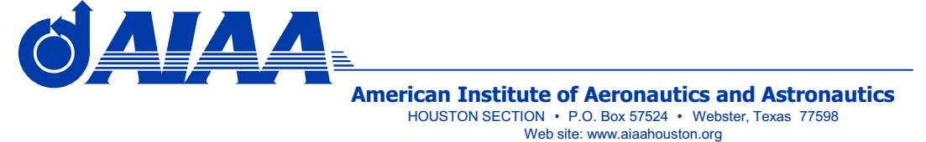

*Annual Technical Symposium 2020*

***AIAA Houston Section***

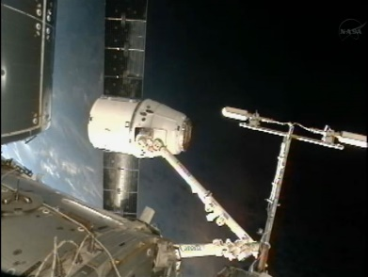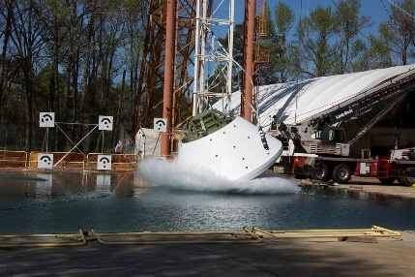

**Topics Include**

* **Aeronautics and Aviation**
* **Astrodynamics**
* **Automation and Robotics**
* **Climate Change and Engineering**
* **Communication and Tracking**
* **EVA, GN&C, In-Space Imaging**
* **International Space Activities**
* **Life Sciences and Human Factors**
* **Propulsion and Power Systems**
* **SR&QA, Systems Engineering**
* **Space Architecture**
* **Space Commercialization**
* **Space Exploration**
* **Space Operations**
* **Structural Mechanics**

**Saturday, October 24, 2020**

**FREE VIRTUAL EVENT**

**Schedule (all times Central Time)**

**08:00 –Meeting Link Opens**

**08:15 - Keynote Address**

**09:00 - Morning Sessions Begin**

**12:00 –Break**

**12:45 – Midday Keynote Address**

**13:30 - Afternoon Sessions Begin**

* **Submit abstracts and register via the ATS 2020 page:** [**http://www.aiaahouston.org/2020-annual-technical-symposium**](http://www.aiaahouston.org/2020-annual-technical-symposium)
* **Two invited speakers: one keynote address, one midday speaker**
* **ATS is open to the public. AIAA membership not required.**
* **Presenters: submit abstracts for presentation, 2) only abstract will be published (no paper required), 3) presentations will be limited to 30 minutes, 4) PowerPoint presentation to be viewable on our web site**
* **All invited to attend and/or present, including university professors and students, NASA/JSC personnel and contractors, K-12 STEM educators, all AIAA members, retirees**

**Friday, October 16 2020 – Abstracts due. (earlier the better)**

**Monday, October 19, 2020 – Authors notified of abstract acceptance**

**For More Information: ATS Co-Chair John DiIorio, john.diiorio@sbcglobal.net**

**ATS Co-ChairWanda Sigur, wasigur@aol.com**