STEM on Station Seeking Help for Student Payload Opportunity

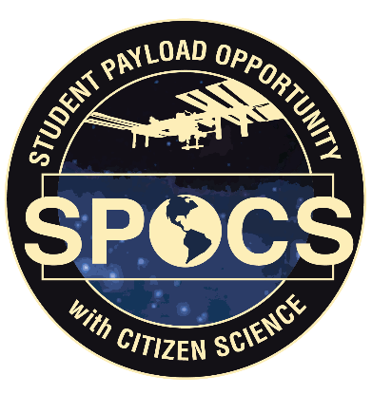
Overview
The International Space Station remains the sole space-based proving ground for reaching the Moon in 2024 through NASA’s Artemis program. To celebrate 20 years of continuous human presence on the space station, STEM on Station will fund five payloads to and from the International Space Station through the Student Payload Opportunity with Citizen Science (SPOCS). Teams of students from institutions of higher learning will propose research related to bacteria resistance or sustainability research. Requirements for the duration of the opportunity include a K-12 citizen science element and educational outreach.

What is your superpower?
STEM on Station is looking for NASA civil servants or contractors with the following superpowers:

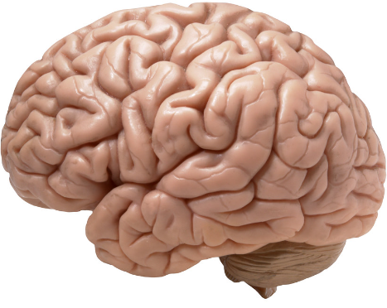
Know-it-all (SME) | Critical Eye (Technical Review) | Guide on the Side (Mentor)
Commitment: 1 hr. webinar plus prep time (Feb 2019) | Commitment: ~5 hours total (April 2020) | Commitment: ~2-5 hr./month (June 2020 – Feb. 2021)
- Subject matter experts for one hour webinars.  - Webinars are 4-5 p.m. CST on Wednesdays in February.  - Topics include:  - Research in Microgravity  - Bacteria Resistance  - Sustainability Research | - Technical Reviewers score proposals based on scientific merit.  - Reviewers have 3-4 weeks to score proposals. | - Mentors provide a NASA connection and support in their specialty.  - Mentors tag-up with teams every other week.

Interested?
Contact STEM on Station team members for more info or to express interest in assisting with SPOCS.
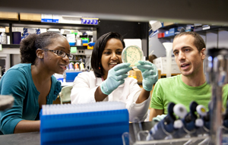
SPOCS Coordinators:
Scott Black scott.w.black@nasa.gov
Jessica Sain jessica.i.sain@nasa.gov

STEM on Station Activity Manager:
Becky Kamas becky.kamas@nasa.gov

