Workshop on Multiple Aspects of Innovation
at NASA Johnson Space Center

Gilruth Recreation Center | Alamo Ballroom
January 29, 2016
Opening Keynote Presentation
Open Innovation – Results, New Capabilities, Strategic Framework
Dr. Jeffrey R. Davis

In this presentation, Dr. Davis will discuss the development and use of open innovation (crowdsourcing) at NASA, results of challenge competitions, the addition of new problem solving capabilities, and the development of an innovation strategy for the future.

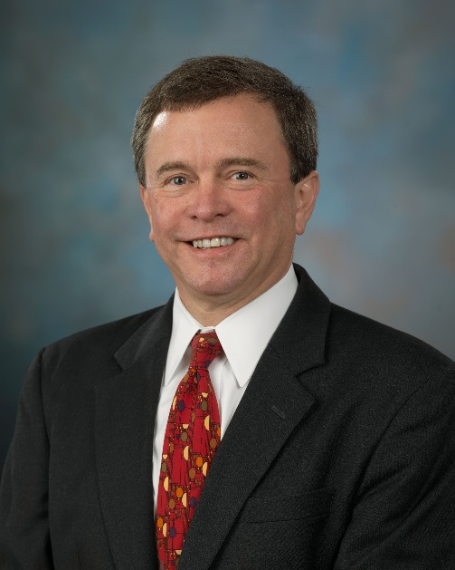
Dr. Jeffrey R. Davis currently serves as Director, Human Health and Performance (HH&P) and as the Chief Medical Officer for the NASA Johnson Space Center (JSC). The HH&P Directorate provides the research and technology development required for exploration as well as all human health and performance support to space flight operations of the International Space Station. The core capabilities in the directorate include space medicine; biomedical research and countermeasures; environmental monitoring; habitability and human factors; strategic planning, benchmarking, and communication; and open innovation/collaboration. Dr. Davis serves as the Director, NASA Human Health and Performance Center (NHHPC), a collaborative organization across government, industry, academia and non-profit organizations; and Deputy Director of the Center of Excellence for Collaborative Innovation (CoECI), a collaborative center to promote the use of prizes within the federal government. Dr. Davis received his B.S. degree in Biology from Stanford University and M.D. degree from the University of California at San Diego. He also holds a Master of Science (MPH equivalent) degree from Wright State University. Past positions include Professor, Clinical Preventive Medicine at the University of Texas Medical Branch; Corporate Medical Director, American Airlines; and Chief, Medical Operations Branch at NASA JSC. He was chair, American Board of Preventive Medicine; chair, Residency Review Committee, Preventive Medicine; president, Aerospace Medical Association; and executive committee, American Board of Medical Specialties. He is co-editor, “Fundamentals of Aerospace Medicine” 2002, and senior editor, 4th edition (publication 2008).

Organizing and Executing Committee (OEC)

General Chair: Mr. Alan Sisson Program Chair: Dr. Kumar Krishen
Executive Chair: Ms. Laura Sarmiento Financial Chair: Mr. Fred Ouellette

