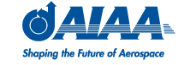

2017 Space Systems AIAA Essay Contest

THE AMERICAN INSTITUTE OF AERONAUTICS AND ASTRONAUTICS (AIAA)
AND THE AIAA SPACE SYSTEMS TECHNICAL COMMITTEE
INVITE YOU TO PARTICIPATE IN A
National Annual Essay Contest
for students in Seventh and Eighth Grade through AIAA Sections

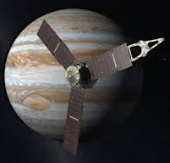

THEME:
Choose one of the aspects of the Juno spacecraft listed on the webpage below. Describe how it works and why it helps discovery at Jupiter. (https://www.missionjuno.swri.edu/spacecraft/juno-spacecraft)
REQUIREMENTS:
• Double-spaced, typewritten (size 12 font) essay, in 1,000 words or less
• Student name, teacher name, grade, and school name must be written in the top right hand corner of the essay
• Include student and teacher name, phone, e-mail, and mailing address for notification and awards
JUDGING CRITERIA:
a) Originality of ideas presented
b) Soundness of logic used to develop ideas
c) Realism of ideas presented
d) Quality of composition and clarity of expression
(Note: All decisions by the judges are final)
PRIZES: At each grade level:
Certificate of recognition
$100 award + $250 for their science classroom
Recognition and essays published by AIAA at a national level
ELIGIBILITY: Any seventh or eighth grader (or equivalent). Please contact your local section officers
(http://www.aiaa.org/RegionSectionMap.aspx) to confirm that they will be running the contest and accepting entries. Entries accepted by “at-large” students through Jeff Puschell, jjpuschell@raytheon.com
DEADLINE: Ask your local AIAA section officers for deadline and where to send entries. Local winners and their teachers will be notified by April. National winners and their teachers will be notified by May.
QUESTIONS: Email Anthony Shao and Erica Rodgers (ant.shao@gmail.com, erica.rodgers@nasa.gov)

