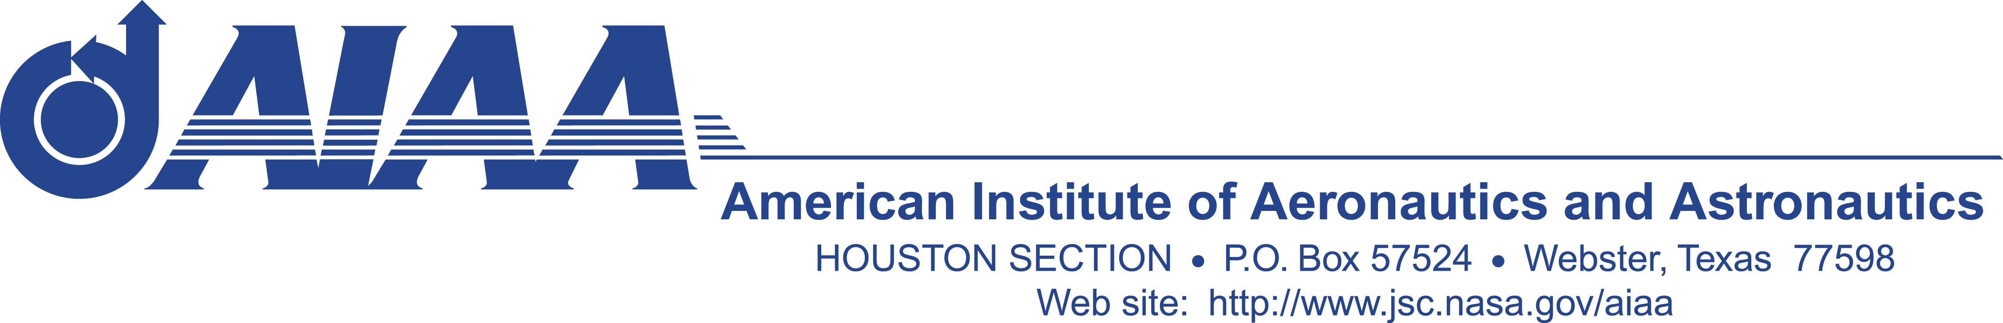

Guidance, Navigation & Control Technical Committee

“Lunch-and-Learn”
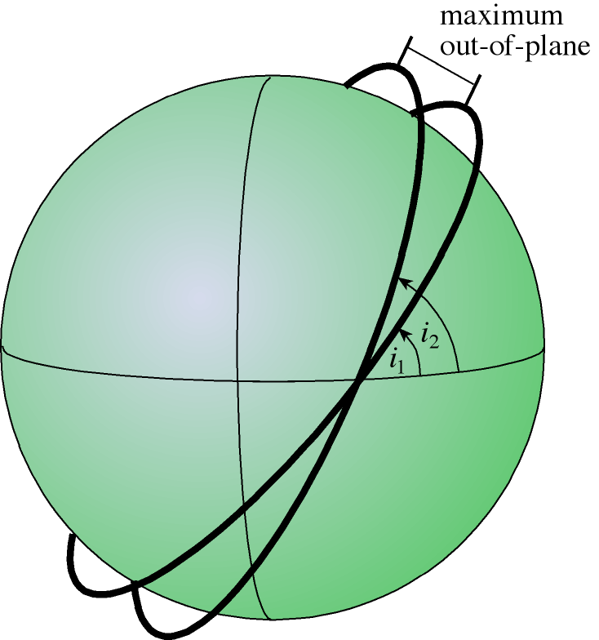
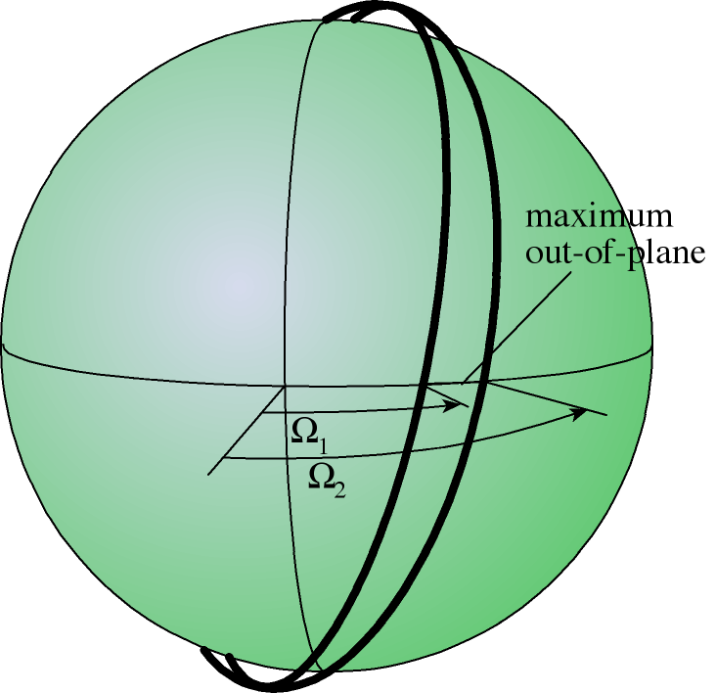

Dynamics and Control of Near-Earth Satellite Formations
by
Srinivas Rao Vadali/Texas A&M University

DATE: August 19, 2003 (Tuesday)

TIME: 12:00 to 1:00 PM
PLACE: NASA/JSC Building 16, Conference Room 113

Formation flying of satellites is currently an active area of research. Some of the proposed NASA and DOD formation flying missions are LISA, ORION, Auroral Lites, Techsat-21, and ION-F. We will overview the basic astrodynamics principles behind the design and control of satellite formations. We will begin with the Two-Body orbital elements and periodic solutions to the Hill-Clohessy-Wiltshire equations commonly used for modeling proximity operations. Next, the above concepts will be extended to include the effects of the perturbation. Mean orbital elements and the so-called -invariant relative orbits will be discussed. Analytical methods for relative orbit propagation for low and high-eccentricity orbits will be presented. We will discuss impulsive and continuous low-thrust control designs for formation establishment as well as reconfiguration. A novel, disturbance accommodating control design process will be presented for minimizing the total fuel consumption of the formation and maintain equal, average fuel consumption of each satellite, over a desired period of time.
Dr. Vadali is a Professor in the Department of Aerospace Engineering at Texas A&M University. His research interests are in the areas of satellite orbit and attitude dynamics, trajectory optimization, and space robotics. He is an Associate Fellow of the AIAA.

If you plan to attend, please get in touch with Murugan Subramaniam at 281-226-5295 or msubramaniam@dynacs.com and leave your contact information. AIAA membership is not required.
Please contact Murugan at least two business days in advance if you require JSC badging.

