AIAA Guidance, Navigation, and Control Technical Committee
"Lunch and Learn"

*******

Flyer Updated
6-13-01.
See Event
Location Change
*******

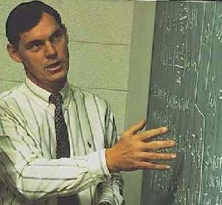

Topic: “StarNav and VisNav: A New Generation of Electro-Optical Spacecraft Navigation Sensors and Algorithms”
By Dr. John L. Junkins, Distinguished Professor, Dept. of Aerospace Engineering, Director of the Center for Mechanics and Control, Texas A&M University

Date: RESCHEDULED TO June 18, 2001 (Monday)
Time: 11:30 AM – 12:30 PM
Place: RELOCATED TO NASA/JSC Building 1, Conference Room 360
(Was Building 16, Conference Room 2124 (Was 113))

Please join us, bring your lunch and a friend, and enjoy the presentation. Dr. John L. Junkins, Ph.D., UCLA (1969) is the founder and Director of the Center for Mechanics and Control (1991-present). Before joining Texas A&M in 1985, he held previous academic appointments at the University of Virginia (1970-77) and Virginia Tech (1978-85). He also held positions at NASA MSFC (1962-65) and McDonnell Douglas (1965-70). He was elected to the National Academy of Engineering, and the International Academy of Astronautics; and is a Fellow, of both AIAA and AAS. He has over 350 publications, including 3 texts, 120 archival papers, and two recent patents. Two new texts are nearing completion. Interests include mechanics, dynamical systems, control theory, optimization, structural mechanics/controls, sensing/actuation, and flight mechanics/navigation/guidance/control of space vehicles; his ideas have been implemented successfully in over a dozen major aerospace and industrial systems. He does theory, computation, experiment, and consults on applied research. He has directed over 60 graduate students, leading to 31 completed PhD students, and 20 MS students, and 11 post-doctoral researchers. He has served as principal investigator for over 60 externally funded research projects, from NSF, NASA, DOD, AFOSR, ONR, ARO, SANDIA and several private industries. He was honored to be the recipient of the AIAA Theodore von Kármán Medal and Lectureship for 1997. In addition to the von Kármán Award, honors include the AIAA Mechanics and Control of Flight Award (1983), the AAS Dirk Brouwer Award (1987), the AIAA John Leland Atwood Award (1988), the AIAA Aerospace Literature Award (1990), the IAF Frank Malina Medal (1999), and the Association of Former Students Distinguished Achievement Research Award, TAMU (2001).
Flyer updated 6-13-01

