

Guidance, Navigation, and Control Technical Committee
“Lunch and Learn”
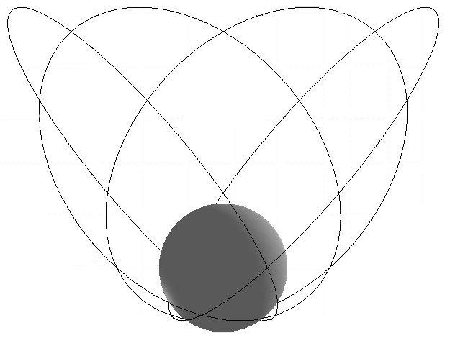
The Flower Constellations:
Continuous Coverage with Repeating Tracks
by

Dr. Daniel Mortari/Texas A&M University

Date: June 11, 2003 (Wednesday)

Time: 12:00 – 1:00 pm

Place: JSC Building 16, Conference Room 113

Please join us, bring your lunch and a friend, and listen to Dr. Mortari discuss “Flower Constellations” a new satellite constellation set which provide continuous coverage of non-equatorial regions with repeatable ground tracks. The flower constellations depend upon two main parameters: N_p, the number of "petals", and N_s, the number of sidereal days to repeat the ground track. Thus, in general, one of the flower constellations is named the N_p/N_s flower constellation. The orbital parameters, the phasing requirements of the satellites, and the number of satellites needed will be analytically derived.

Dr. Mortari is an Associate Professor (full-time) at Texas A&M University. He earned his Doctor of Engineering degree from the University of Rome (Italy) in 1981, where he worked as an Assistant Professor from 1992 to 2002. Other work experience includes teaching courses at the Industry “Officine Galileo” and at the University of Perugia (Italy), and consulting with The Charles Stark Draper Laboratory in 2002. He was included in the NASA Group Achievement Award (San Marco Project).

If you plan to attend, please get in touch with Douglas Yazell at 281-244-3925 or douglas.yazell@honeywell.com and leave your contact information. AIAA membership is not required. Please contact Douglas at least two business days in advance if you require JSC badging.

