“Lunch and Learn”
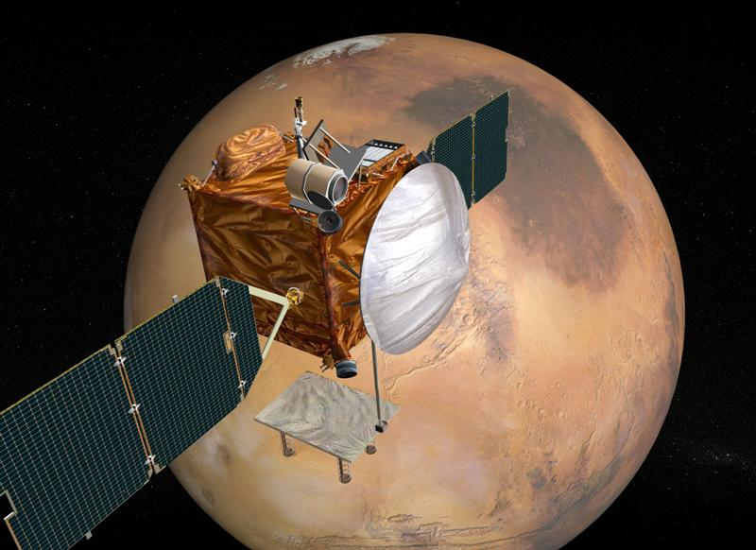

The AIAA Houston Section Astrodynamics Technical Committee presents
Hierarchical Navigation Algorithms In Support of Mars Exploration
Dr. Robert H. Bishop
Department of Aerospace Engineering and Engineering Mechanics
The University of Texas at Austin

Date: May 19, 2005 (Thursday)

Time: Noon - 1:00 pm

Place: JSC Building 16, Conference Rooms 111 and 113

Exploration spacecraft navigation currently relies on navigator experience and ad hoc techniques for the resolution of anomalous residual signatures from the operational tracking filter. Difficulties navigating recent missions, such as modeling the solar radiation pressure surface on MPL, or detecting off-nominal atmospheric density profiles during planetary entry for the MER landings, have illustrated the need for a systematic method of resolving anomalous behavior in the tracking solution. A modular navigation architecture employing banks of extended Kalman filters regulated by gating networks has been proposed to alert the navigator that a shift from optimal to suboptimal filtering has occurred. The architecture of the proposed navigation system will be presented and discussed. Results using Mars Pathfinder tracking data obtained from the Deep Space Network will be used to illustrate the capabilities of the navigation system to detect very small unmodeled thrusts in a timely fashion. Extensions of the adaptive navigation architecture to planetary entry, descent, and landing will be introduced and preliminary results presented.

Please bring your lunch and a friend. This free event is open to the public. AIAA membership is not required. If you plan to attend, registration is recommended and will be easy to do online at www.aiaa-houston.org. If you require JSC badging, please register 3 days in advance (citizens) or 2.5 - 3 weeks in advance (non-citizens). For additional information, contact Douglas Yazell at 281-244-3925 or douglas.yazell@honeywell.com.

Learn more about the AIAA Houston Section at http://www.aiaa-houston.org

